Travelling Salesperson Problem – Brute Force

Lindie Chenou
[Computer Science & Engineering]
Speed School of Engineering
University of Louisville, USA
lcchen01@louisville.edu

- Introduction (What did you do in this project and why?)
The goal of this project is to calculate the optical cost of visiting each city in a data file. The problem is best known as A Traveling Salesperson Problem (TSP). TSP is an NP-complete problem. Depending on how many nodes or cities are given, the salesman must visit each one using the minimum cost it will take to get it done.
- Approach (Describe algorithm you are using for this project)
For this project, Python was used to execute the problem. For this project, it was expected to have a brute force algorithm to produce the output expected. Brute force Algorithms are actually what they sound like; clear strategies for taking care of a difficult that depends on sheer processing power and attempting each chance instead of cutting-edge procedures to improve proficiency. The code must be able to open a file name an read the input for each city coordinate. With the coordinates input starting inline 7 for each input file; the code must have been able to get rid of the first 7 lines since they were useless.
The distance from each node to another is calculated before the permutation function. After which the permutation was generated and calculated the total cost of each permutation, from that found the smallest one.
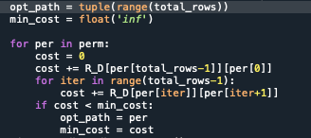
- Results (How well did the algorithm perform?)

  - Data (Describe the data you used.)
A set of cities and their coordinates where provide. Having a file from 4 cities and their coordinates to a file of 12 cities.
  - Results (Numerical results and any figures or tables.)
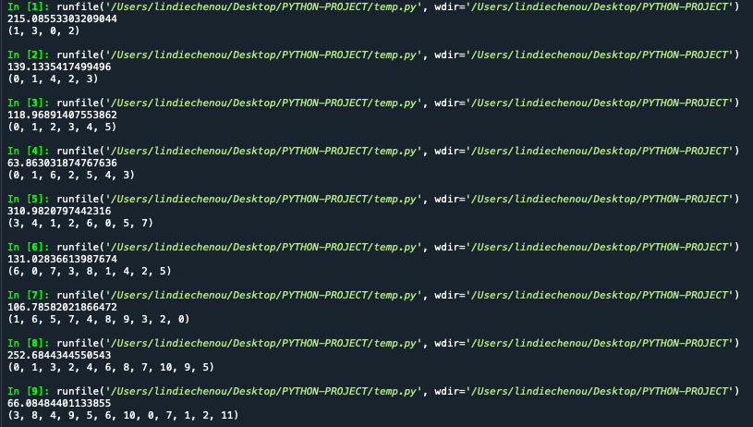

- Discussion (Talk about the results you got and answer any specific questions mentioned in the assignment.)
For the lower count of cities, it only took about a couple of milliseconds to obtain the results. The reason for this because the amount of permutation generated that the code has to go through. For the 4 cities file, there is only 24 permutation that the code has to go through. From Random4.tsp to Random7.tsp the result was less than a second. From the 8 cities file, you can’t see the delay to get the result for that particular file. For Random10 it took about 15 seconds for the computer to generate the result. It took about 5 minutes for the 11 cities, and for the longest one the 12 cities had a significant time delay. It took about 40 minutes to get the result for the 12 cities file.
- References (If you used any sources in addition to lectures please include them here.)

